Akshaya’s Self QA Analysis - USER STORY 1052189 (QA-1109070 Price Exceptions View Inactive - Testing

View Inactive Price Exemptions

Screenshot:
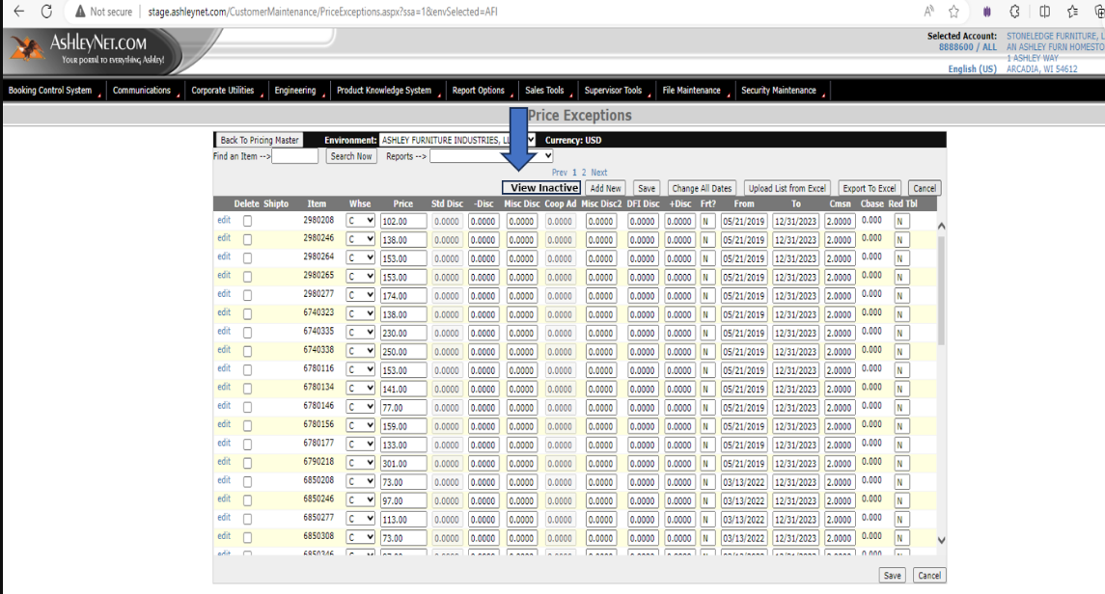
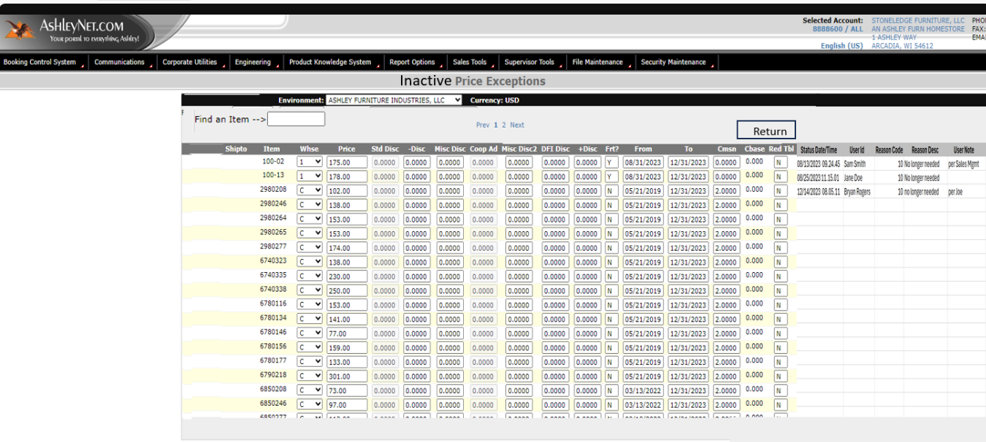
Story:
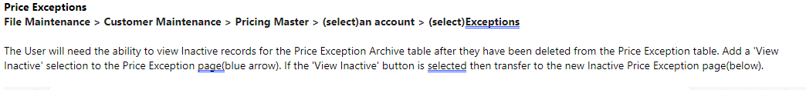
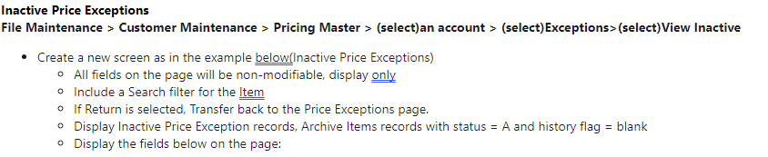
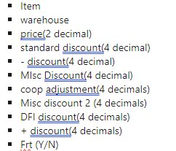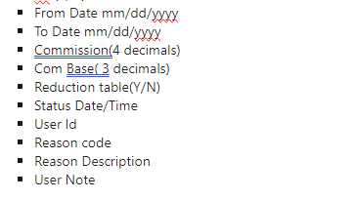

QA Analysis:
As a User I want to see the “View Inactive” Button from Price exceptions on clicking that button it should take me to the “Inactive Price Exceptions” Page.
- Upon deleting the items from the Price exceptions page on clicking the view inactive should display the deleted items from the exception page in the inactive page
- There should be an option “Find an Item” with Search Button in the inactive page
- There should be a “Return” Button in the Inactive page where on clicking the button takes me back to the price exceptions module
  - To validate the columns mentioned above are displayed
- Find an item shows only the items/item available in the “Inactive Price Exceptions” Page
- SQL-Archive “A” Flag= “H” to be validated.

Testing Planning Phase

  - SQL Testing can be involved If Requires
  - To do Smoke, Sanity (if Bug retests) and Smoke-Regression
  - Test scenarios to be covered for both Positive and Negative whole and split wise.
  - Testing Includes both Positive and Negative
Discussion with Developer-Suresh to Be continued...
Change in document is possible post discussion.

Test Scenarios:

1.To Verify View Reactive is available in price exceptions page
2.To verify the non-deleted items no show in the inactive price Exceptions page
3.To verify “Find an Item” is available
4.To verify "Search Button”
5.To verify "Return” Button
6.Positive Full Flow
7.Negative Full flow
8.SQL Testing
9.From Bill To /Ship to Master
10.Columns validation

